**Lab 30**

**Configuring Lamp stack using Lightsail**

**Reference:** https://aws.amazon.com/about-aws/whats-new/2016/11/introducing-amazon-lightsail/

Lightsail is designed to be the easiest way to launch and manage a virtual private server with AWS. Lightsail plans include everything you need to jumpstart your project – a virtual machine, SSD-based storage, data transfer, DNS management, and a static IP – for a low, predictable price.

Fast & Easy  
  
With Amazon Lightsail, you can deploy a virtual private server with just a few clicks using preconfigured templates for your favorite Linux distribution, application, or dev stack – including WordPress, Magento, LAMP, and more. Once your virtual private server is deployed, Lightsail’s intuitive management console makes running your server and its associated services a breeze.

Built on the World’s Leading Cloud  
  
Lightsail virtual private servers run on the same highly available and reliable AWS cloud infrastructure used by millions of customers. This means that your app gets to use the same trusted and proven cloud infrastructure that powers companies like Netflix, AirBnB, General Electric, and Capital One.

Grows with You  
  
Lightsail allows you to grow and scale your applications over time. When your app needs advanced features like managed databases, content delivery network, or any of dozens of other features, you can connect these AWS services to your Lightsail-hosted application.

Low, Predictable Price

Lightsail offers bundled plans that include everything you need to deploy a virtual private server – including a virtual machine, storage, and networking – starting at a flat $5 per month. As your needs grow, you can trade up to larger plans or add resources.

Click “Lightsail” service

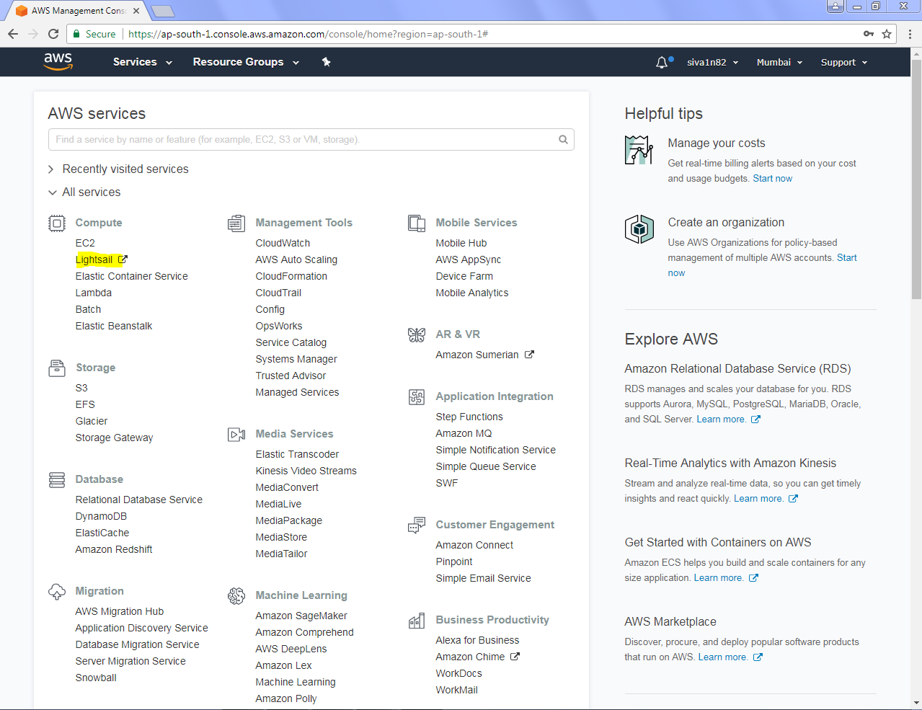

Click “Create Instance”.

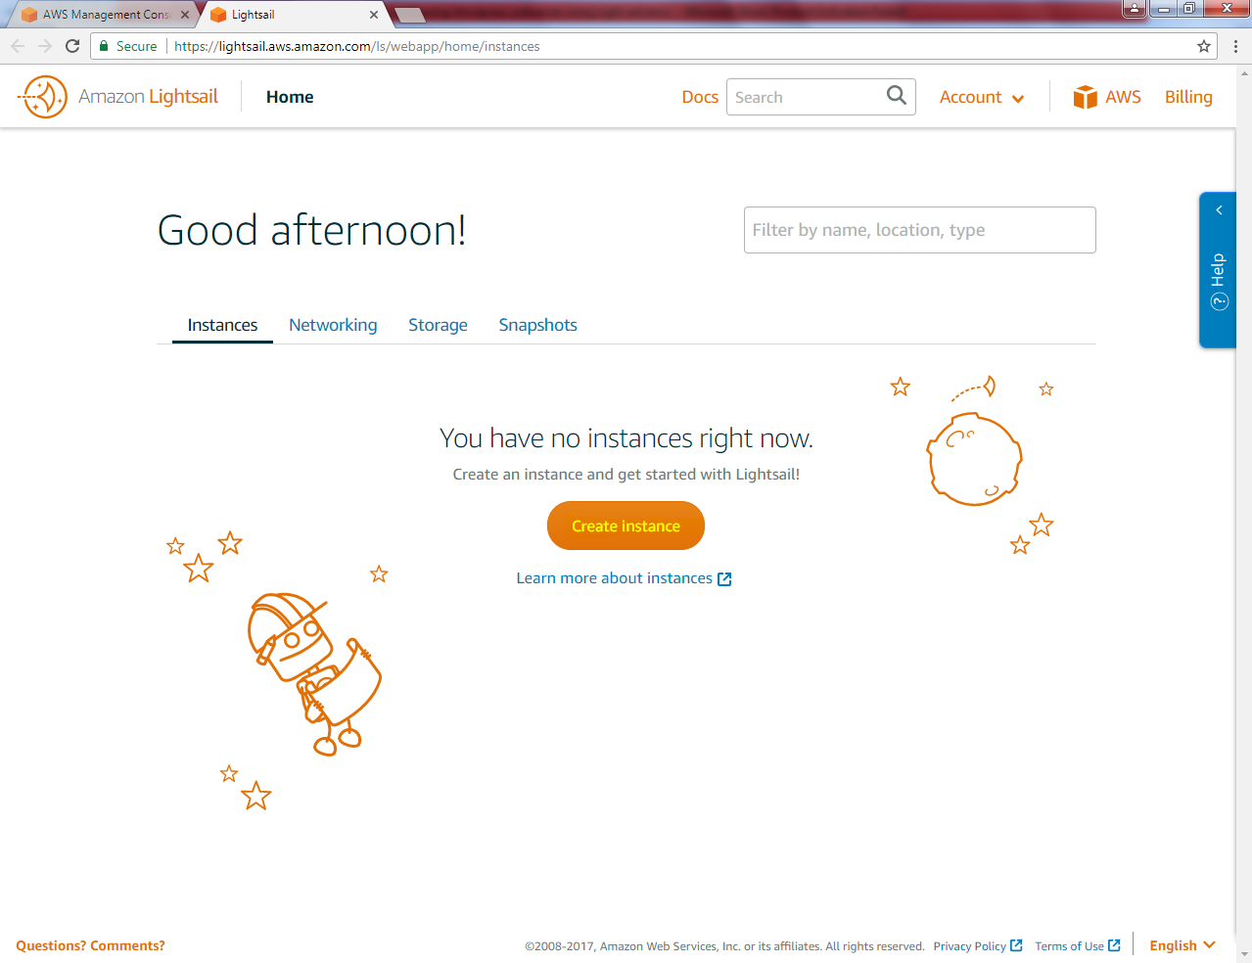

You need to observe that Instance will be created in Mumbai region,

Select Linux and Select App + OS (Lamp stack).

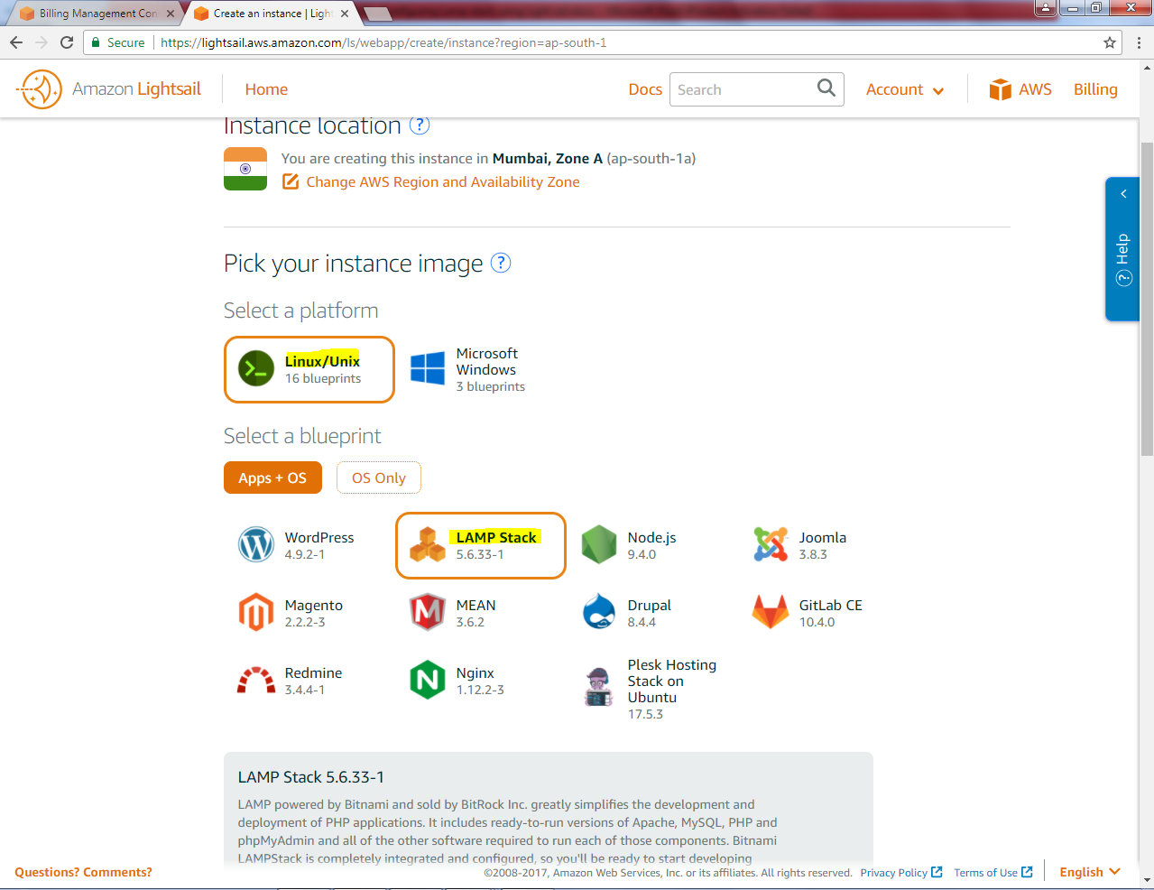

Select Instance plan as one month free offer. And type instance name as Sansbound_LAMP.

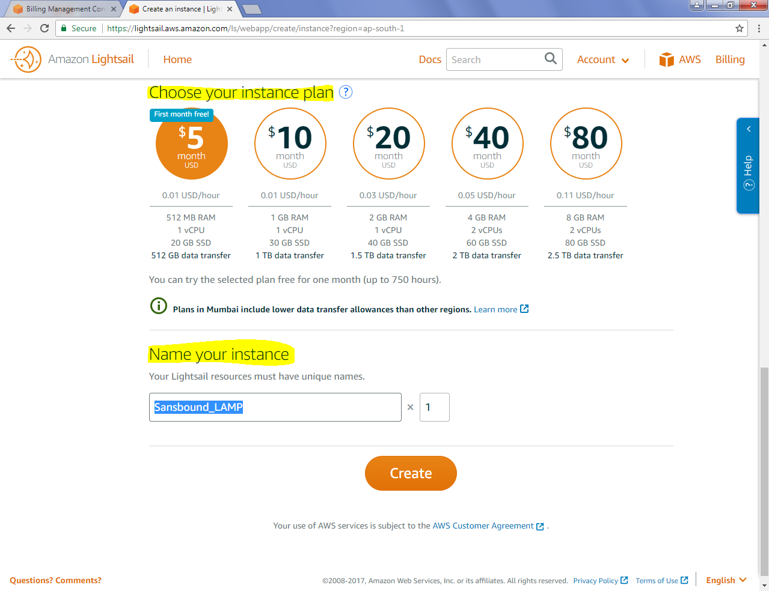

Now it’s pending state.

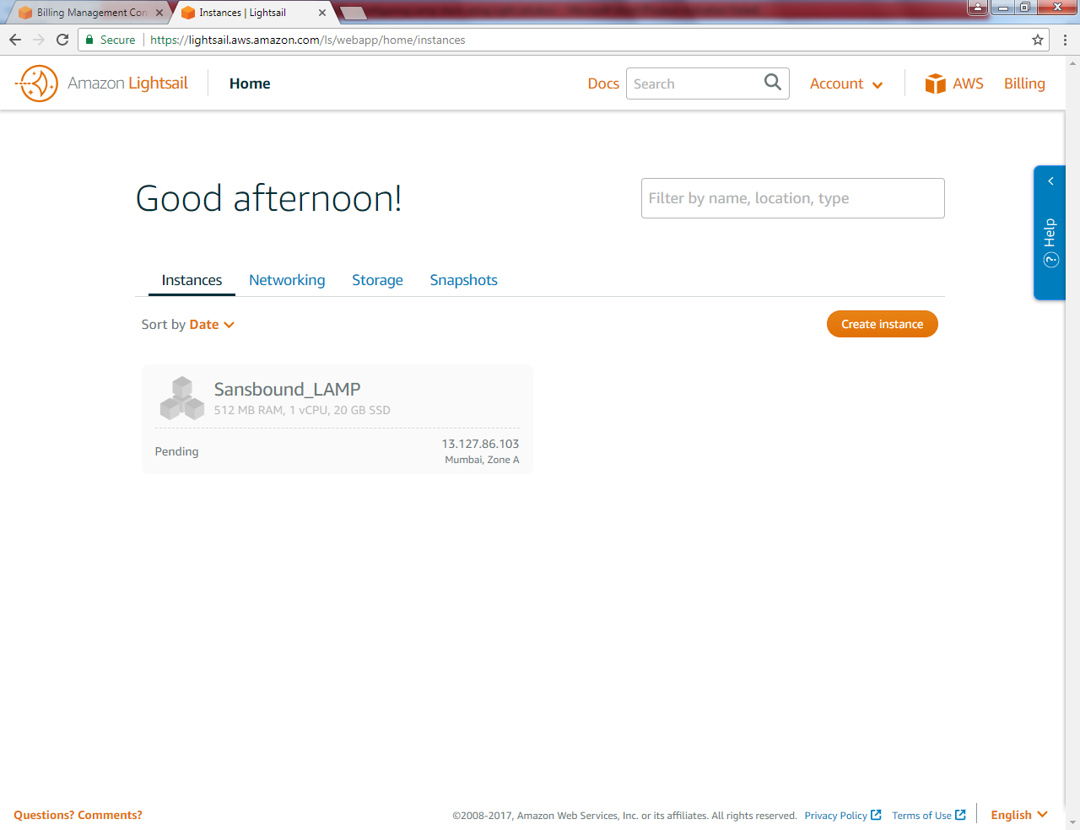

Now type <https://13.127.86.103> (i.e. IP address of Instnace).

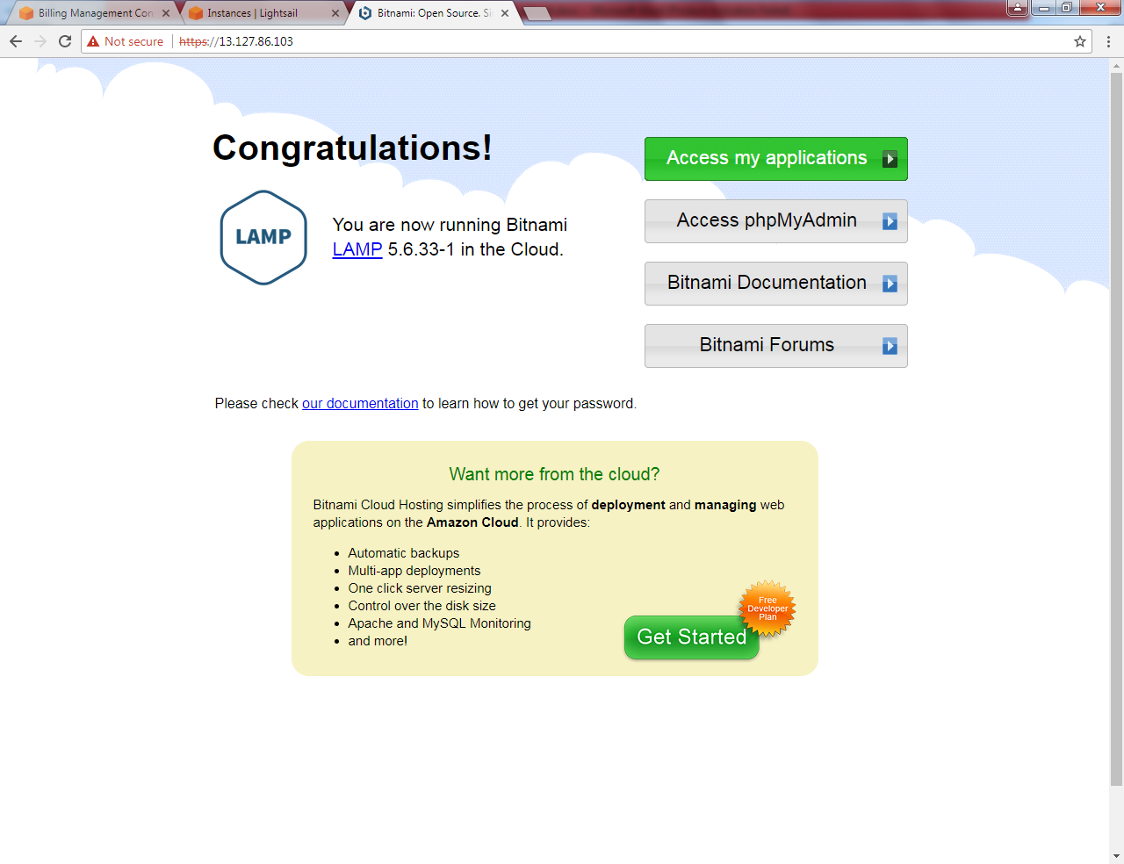

**Need to delete the instance once testing completed.**